The Bridge Movements plug-in ArcGIS uses Squee-SAR data along bridges to detect vertical movement. Depending on the amount of movement over time, the bridges of interest are colored one of three colors: red, yellow, or green. If there is minimal movement, the bridge is colored green, signifying a bridge that is in good condition. If there is moderate movement, the bridge is colored yellow, signifying a warning that the bridge may be in poor condition. If there is significantly high movement above a threshold set by bridge engineers, the bridge is colored red, signifying that the bridge is in critical condition and must be examined and possibly repaired. The bridge most recently found in critical condition is zoomed to on the map after running of the Bridge Movements toolbox, as shown in Figure 1. Points on the bridge are labeled with their height (mm) and average velocity (mm/year.)

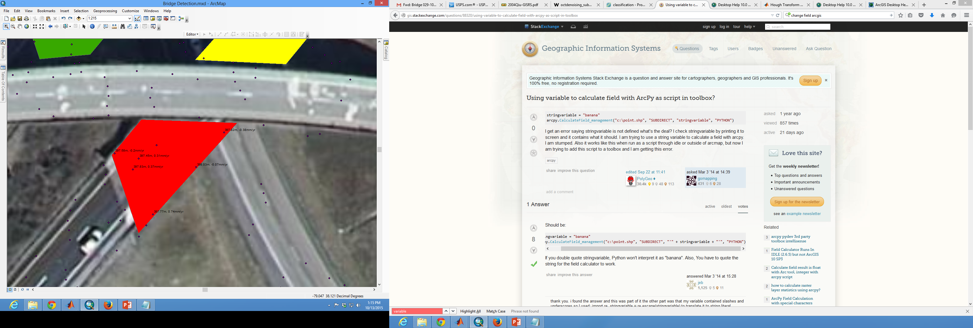

Figure 1: Zoomed to Critical Bridge

A shapefile of bridges, shown in Figure 2, is used with the Squee-SAR data points for analysis. Data points on the bridges are selected to perform the following calculations. First, the points on a bridge are compared by height. The median height is taken for all points on a selected bridge. Then, all points within the selection are compared to this median height. Any points 3 meters or more below the median height are assumed to be on the road beside or below the bridge, and are removed from the selected data.

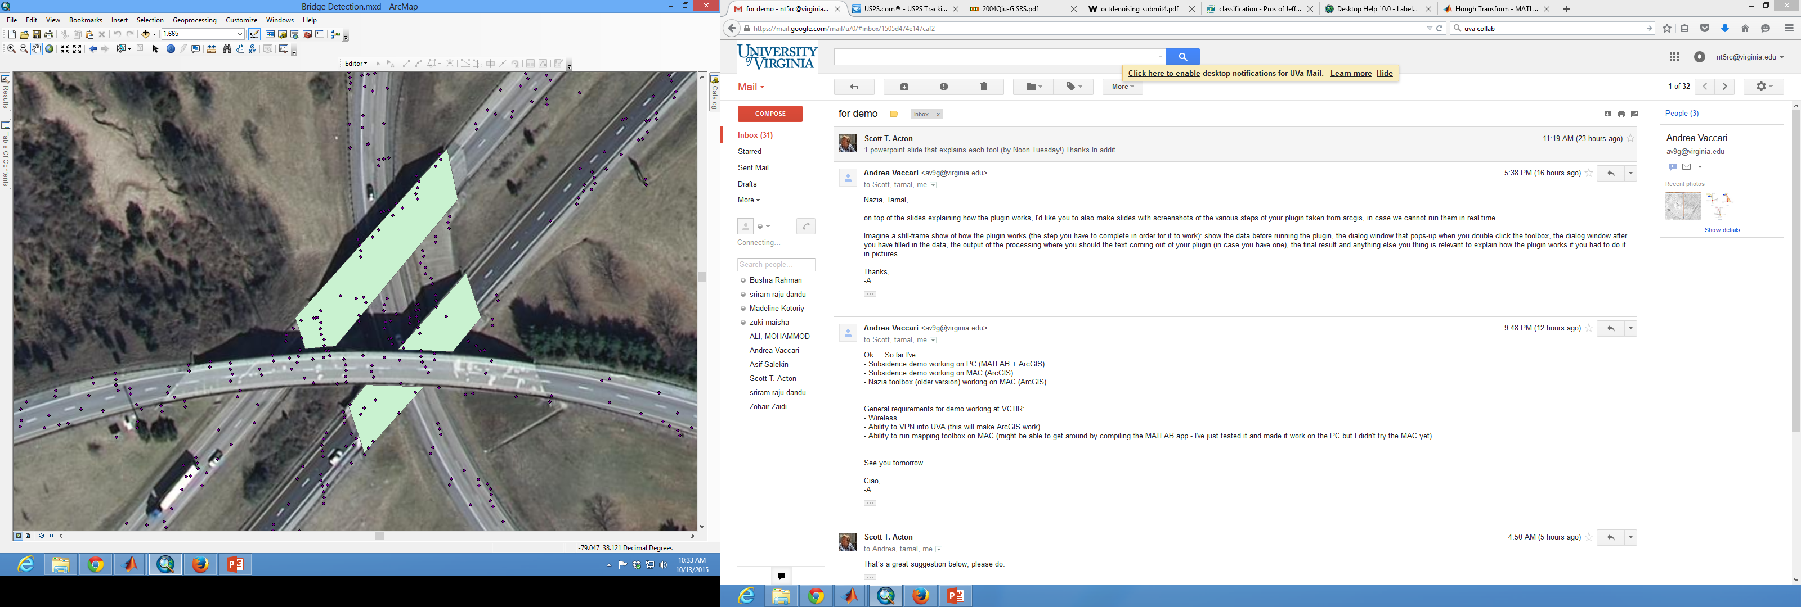

Figure 2: Shapefile of Bridges

There are two thresholds used in the Bridge Movements toolbox: the warning threshold and the critical threshold. The critical threshold is movement at or above .5 inches per month. The displacements from month to month are used to calculate velocities for each month (for each point.) If any of these monthly velocities exceed .5 inches per month, then the critical alarm is raised, and the bridge is colored red. These monthly velocities are then used to calculate whether or not the points on the bridge exceed the warning threshold. The warning threshold is set to movement at or above 1 inch per year. To calculate whether or not the bridge is moving at this rate, the monthly velocities are aggregated. The median velocity is calculated for each point on an array of the points’ monthly velocities. If any of these median velocities exceed 1 inch/year movement, then the warning alarm is raised, and the whole bridge is colored yellow. Coloring of the bridges is done according to a separate symbology file.

While the toolbox is running a dialog box appears (Figure 3), detailing the coordinates of each bridge, how many points are being analyzed, and the condition of the bridge: good, warning, or critical. To give a sense of runtime, analyzing 17 bridges takes about 16.4 seconds on a standard machine. The coordinates and conditions for each bridge are also saved in an output file that can be accessed for later investigation.

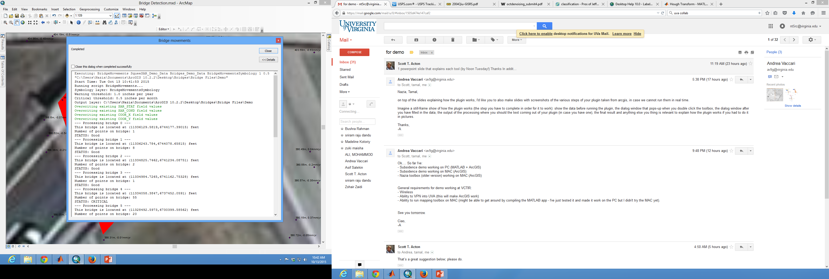

Figure 3: Toolbox Running

To use the Bridge Movements toolbox, a shapefile of the bridges of interest must be created. A dialog box will pop when the tool is double-clicked (Figure 4), with fields that can be filled out. The Squee-SAR data, bridges, and a color symbology file all must be selected. The fields for the critical and warning thresholds are also provided, filled in with the suggested parameters. These can be tweaked according to user preferences. The output field can be filled according to where the user wishes the output file to be placed – however, the file should not be placed in the Default GDB directory as using this directory with the current version of the toolbox results in errors.

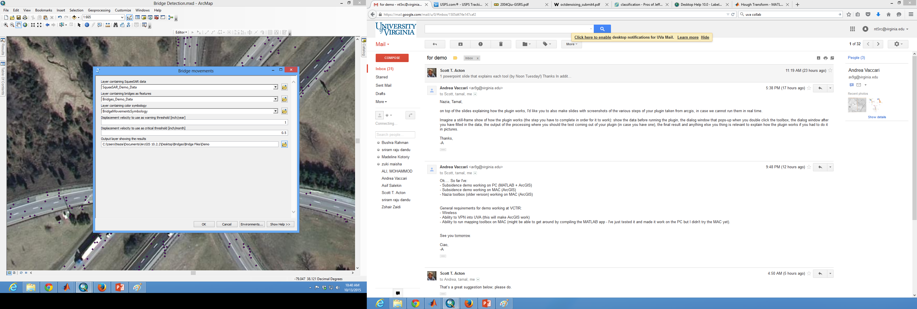

Figure 4: Before Running the Toolbox

Results from running the toolbox can be seen in Figure 5.

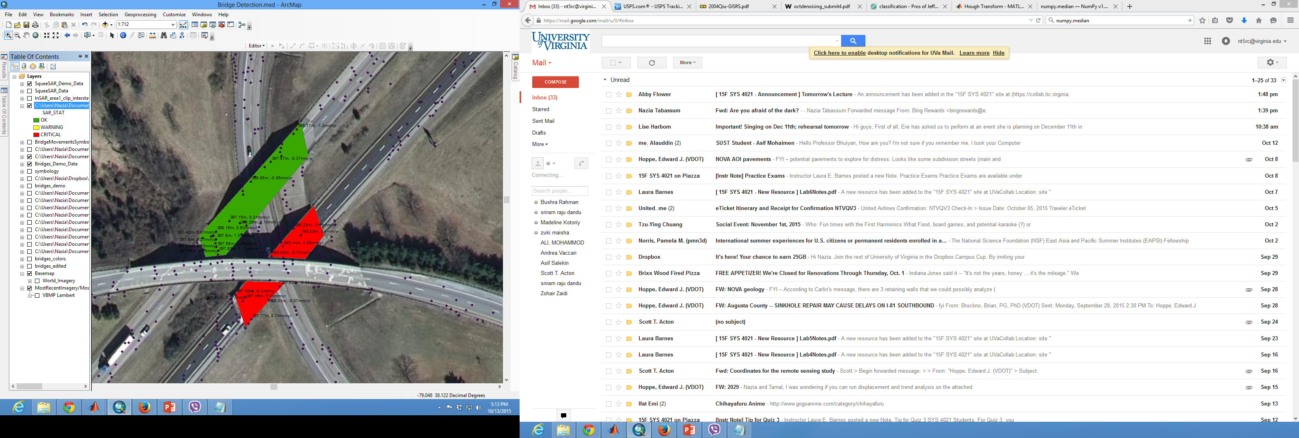

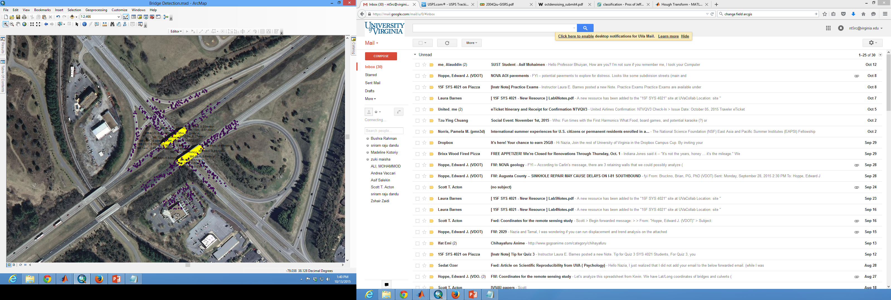

Figure 5: Results of Toolbox